**Author Name**: Michael Eziashi Osadebey

Department of Applied Physics and Electronics,

Umea University, Umea

Sweden

**Title**: INTEGRATED CONTENT-BASED IMAGE RETRIEVAL USING TEXTURE, SHAPE AND SPATIAL INFORMATION

**Issues**: Content-based image retrieval (CBIR) systems demonstrate excellent performance at computing low-level features from pixel representations but its output does not reflect the overall desire of the user. The systems perform poorly in extracting high-level (semantic) features that include objects and their meanings, actions and feelings. This phenomenon, referred to as the semantic gap, has necessitated current research in CBIR systems towards retrieving images by the type of object or scene depicted. Analysing and interpretation of image data in large and diverse image database, as in a CBIR system is obviously difficult because there is no prior information on the size or scale of individual structures within the images to be analysed.

**Methodology:** 

**Conclusion**: Current and most CBIR systems focus on colour as primary feature for retrieval. In this thesis colour is de-emphasized. Focus is on texture as primary feature. Shape and spatial information were secondary features. This can have varied applications such as the police who maintain an image database of criminals, crime scenes can search for the clues using shape and spatial information of the images in the database. Similarly it can also be used in medical profession, architectural and engineering design etc.

**Author:**Dr.K ASHOK BABU Professor & HOD of (ECE)

SRI INDU COLLEGE OF ENGG&TECHNOLOGY

**Title**:IMAGE RETIEVAL COLOR, SHAPE AND TEXTURE FEATURES USING CBIR

**Issues**: Content-based image retrieval (CBIR) is an important research area for manipulating large amount of image databases and archives. Extraction of invariant features is the basis of CBIR. Using Just two feature information for comparing image May cause inaccuracy than compared with using more than two features Accuracy high. The authors are focussing on Using three features for image Retrieval like colour, shape & texture Feature; we use HSI colour information especially HUE Value and CSS (curvature scale space) as shape information. As a result these three features combined together fulfil the aspect of retrieval in Image.

**Methodology: **

This project be formed 4 steps propose, pre-processing, extract of feature, store information of Image and retrieval the Image. We used CSS (Curvature Scale Space) and HSI (Hue, Saturation, Intensity) to extract the feature points. On pre-processing, implement the Image processing for next step. Extract the RGB of pixel colour information for colour feature and the gravy-level of pixel information for shape feature. On extract of feature, can extract feature of visual, this is retrieval. This is consisting of vector of feature that base on the

Retrieval similarity measure from colour and shape. Extract process of colour information show up the progress that transfers from original image data RGB value to HSI value (as there is the flexibility to represent in the 2-Dformat). On extract of shape, one of step for can get the CSS Image, extract edge after transfer inputted colour image to gray-level (to eliminate high intensity values and deviation of the shape). Here every object is represented in x and y coordinates of its boundary (binary images) points. Obtain the CSS image after extract

contour by progress of contour tracking (smoothening of edges) then, remove the noise by clustering (technique for statistical data analysis used to extract meaningful information). On storage information of image, efficiently can be storage and management the feature information of image and, store the vector and linked image file

though the indexing progress on an image. Then, as last step, retrieval progress of image and measurement of similarity, extract and show up the best of quality. For example, user query by example image to here, first time extract maxima coordinates value store from between vector of feature and image database then, compare the

vector with the CSS image of query image. After output the image follow the top priority.

**Conclusion**: The approach of using only one single feature to retrieve an images from the database is inaccurate .In order to overcome these inaccuracies we have to use an approach of retrieving images based on all three features together i.e shape,color,and texture.

**Author**: Neetu Sharma, Paresh Rawat, Jaikaran Singh

**Title:** Efficient CBIR Using Color Histogram Processing

**Issues:** The need for efficient content-based image retrieval system has increased hugely. Efficient and effective retrieval techniques of images are desired because of the explosive growth of digital images. Content based image retrieval (CBIR) is a promising approach because of its automatic indexing retrieval based on their semantic features and visual appearance. However users have difficulties in representing their information needs in queries to content based image retrieval systems. In this survey we investigate two methods for describing the contents of images. The first one characterizes images by global descriptor attributes, while the second is based on color histogram approach.

**Methodology:**

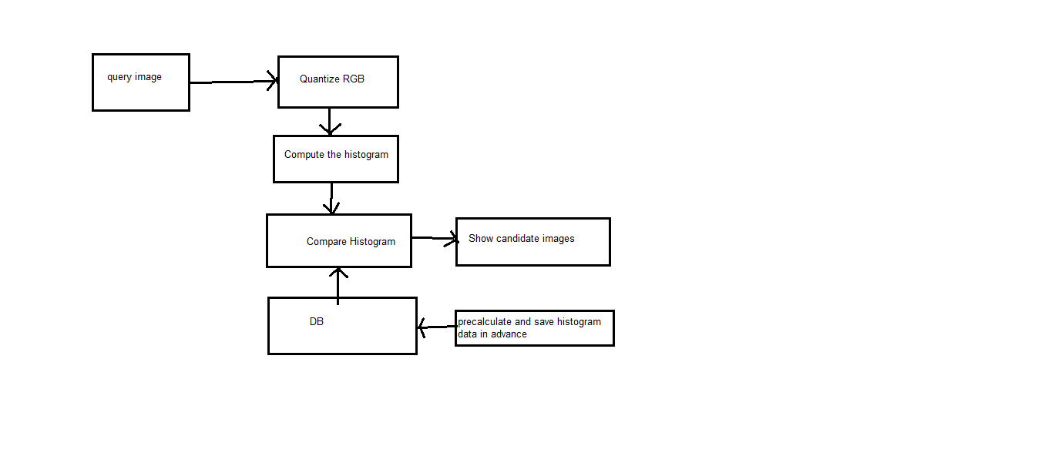**Conclusion:** Histogram search characterizes an image by its color distribution, or histogram but the drawback of a global histogram representation is that information about object location, shape, and texture is discarded. Thus this paper showed that images retrieved by using the global color histogram may not be semantically related even though they share similar color distribution in someresults.This drawback is also minimized upto some limit by calculating color feature attributes along with efficient implementation.

**Author**: James C. French , James V. S. Watson , Xiangyu Jin, W. N. Martin

Department of Computer Science

University of Virginia

**Tittle:** Integrating Multiple Multi-Channel CBIR Systems

**Issues**: In this paper we show that we can also merge the results of multiple CBIR systems to

achieve even greater retrieval effectiveness again without changing the underlying CBIR technology. We also present an example of this combined approach and show that it can dramatically improve retrieval effectiveness in content-based image retrieval systems.

**Methodology:**

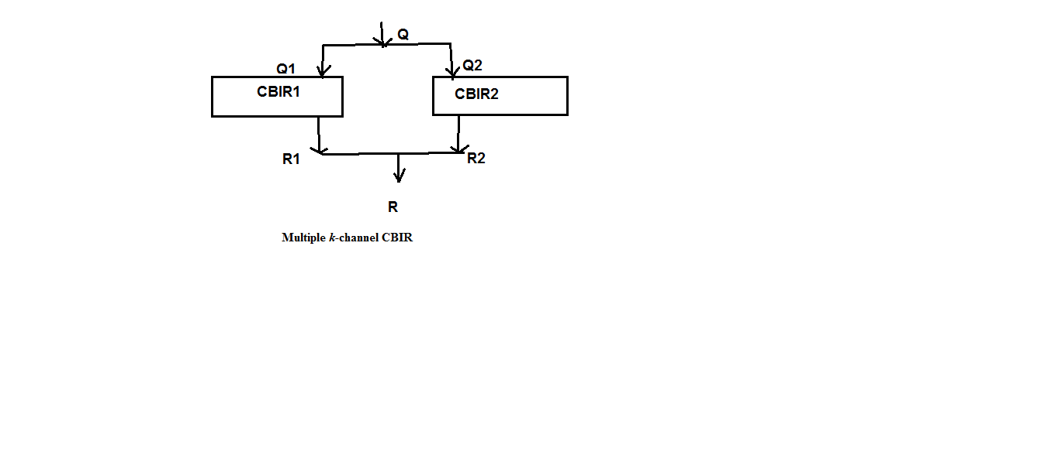

**Conclusion:** The survey describes a simple approach for improving the retrieval effectiveness of conventional CBIR systems. The approach treats the CBIR technology as a black box which can be used to provide different channels of retrieval results for subsequent merging or for use in interactive retrieval interfaces. The channels are implemented as additional indexes over simple image transforms. Our approach offers a simple, cost-effective strategy for boosting the performance of CBIR systems.

**Authors**: Minakshi Banerjee, Malay K. Kundu, Pradipta Maji

Center for Soft Computing Research, Indian Statistical Institute, 203, B. T. Road, Kolkata 700 108, India

**Tittle**: Content-based image retrieval using visually signiﬁcant

point features

**Issues**: Effective image retrieval from a large database is a difﬁcult problem, and is still far from being solved. Hence, the retrieval of relevant images, based on measuring the similarity between automatically derived features (color, texture,shape, etc.) of the query image and that of the images stored in the database, a problem popularly known as content-based image retrieval (CBIR) , is a highly challenging task.

In conventional CBIR approaches, an image is usually represented by a set of features, where the feature vector is a point in a multidimensional feature space. Each feature tries to capture only one property of the image, such as color, texture, shape, etc. It is therefore necessary to select the optimal set of features suitable for a particular type of query, in which the component features may also be varied according to their importance.

**Methodology:** This paper presents a new image retrieval scheme using visually signiﬁcant point features. The clusters of points around signiﬁcant curvature regions (high, medium, and weak type) are extracted using a fuzzy set theoretic approach. Some invariant color features are computed from these points to evaluate the similarity between images. A set of relevant and non-redundant features is selected using the mutual information based minimum redundancy-maximum relevance framework. The relative importance of each feature is evaluated using a fuzzy entropy based measure, which is computed from the sets of retrieved images marked relevant and irrelevant

by the users. The performance of the system is evaluated using different sets of examples from a general purpose image database.The robustness of the system is also shown when the images undergo different transformations.



**Conclusion:** In the current work, major emphasis has been placed on developing signiﬁcant feature descriptors and selecting an optimal set of features suitable for retrieving a set of images perceptually relevant to the query image. From different query examples and classiﬁcation results using different training sets on a standard database, it is shown that a single set

of features may not be suitable for handling all types of queries. The set of features that may be able to retrieve images with a range of illumination variations may fail to retrieve noisy images. To overcome such limitations, the features are combined and the weights are updated to obtain a trade-off between feature selection and accuracy in the case of retrieving from an unknown database. Although the proposed CBIR system is not capable of handling very complex

types of queries, it can identify relevant images that differ visually in some characteristics due to translation, rotation, scaling, blurring, illumination change, etc. The suitability of the proposed features may be increased if the application is extended to speciﬁc images like logos or facial images, rather than general purpose images. To achieve these goals we shall try to introduce other sophisticated features and incorporate some other mechanism, like surrounding text for

web images, to obtain better applications**.**